**Vicnet, State Library of Victoria**

2009

**Dhøg Cøllø**

**Win32 Keyboard layouts (Vista and Win7)**

**Andrew Cunningham**

© State Library of Victoria and Australian Chollo Community Inc. 2009



This work is licensed under a [Creative Commons Attribution-Noncommercial-Share Alike 2.5 Australia License](http://creativecommons.org/licenses/by-nc-sa/2.5/au/).

The keyboard layouts were developed by Vicnet, a division of the State Library of Victoria, as part of the Open Road project’s Language enablement initiative. The keyboard layout was developed for the Australian Chollo Community, Inc.

This manual was developed by [Vicnet](http://www.vicnet.net.au/), a division of the [State Library of Victoria](http://www.slv.vic.gov.au/) as part of the [Open Road](http://www.openroad.net.au/) project’s Language enablement initiative.

# Installing a Chollo keyboard layouts

The Chollo Win32 style keyboard layouts can be downloaded from <http://www.openroad.net.au/chollo>

There are two Chollo keyboard layouts available:

1. **Dhøg Cøllø**, the file is called chollo.zip; and
2. **Dhøg Cøllø (QWERTY)**, the file is called cholloq.zip

To install the keyboard layouts:

1. Download one or both of the keyboard layouts
2. Double click on the zip file.
3. Double click on the file **setup.exe**.
4. Follow Windows’ prompts.

If double clicking on the **setup.exe** file doesn’t start the keyboard installation process, you will need to:

* Click on the **setup.exe** file using the right mouse button. A pop-up menu will appear.
* Click on the **Run as administrator** menu option.

# Using the Chollo keyboard layouts

# Selecting a keyboard

1. Open your application, select the font to wish to use, and click in the text area to ensure your application has keyboard focus.
2. Click on the Language icon at the bottom of the screen.   
     
   The language icon is an icon with two letters in the system tray at the bottom right of your computer screen. In the image below the language icon says **EN**. This is the language code (abbreviation) for English. And indicates that the current input locale is English.

01.JPG

1. Select the **Chollo (Sudan)** input locale from the popup list of keyboard layouts.

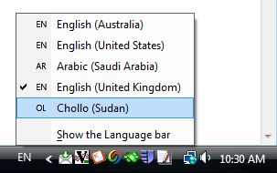

The keyboard icon will change to **OL** (Other Languages).

04.JPG

Windows keeps track of the input locale for each application window. Changing a keyboard layout, only changes the keyboard layout for the current application window. All other application windows remain unchanged.

### Selecting a keyboard when both Chollo layouts are installed

It is possible to have more than one keyboard layout assigned to each input locale (language). If you have installed both the **Dhøg Cøllø** and the **Dhøg Cøllø (QWERTY)** keyboard layouts then the input locale name will change.

1. Select the **Other Languages** input locale from the popup list of keyboard layouts.

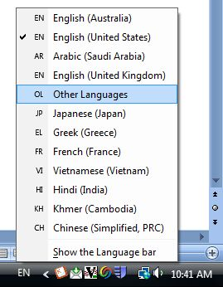

The keyboard icon will change to **OL** (Other Languages), and an additional keyboard icon will be displayed

08.JPG

When more than one keyboard layout is available, a keyboard icon will be visible to the right of the language code icon of the current input locale. If you click on the keyboard icon you will be able to select an alternative layout for that input locale/language.

1. Click on the keyboard icon and select the required keyboard layout form the popup menu.

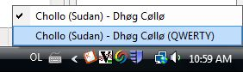

## Windows virtual keyboard

The virtual keyboard can be started via the Start button. Your system administrator may have added a keyboard shortcut to the desktop. If there is a desktop shortcut, double click on the shortcut to start the virtual keyboard.

1. Click on the Windows **Start button**.
2. Type “**osk.exe**” into the search prompt at the bottom of the popup menu.

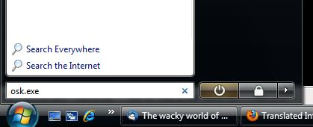

1. Press the **Enter** key. This will start up the Onscreen keyboard.
2. Click in the input field or text area to regain keyboard focus.
3. Move your mouse over the virtual keyboard and back to the web browser. The virtual keyboard should be displaying the required language keyboard.

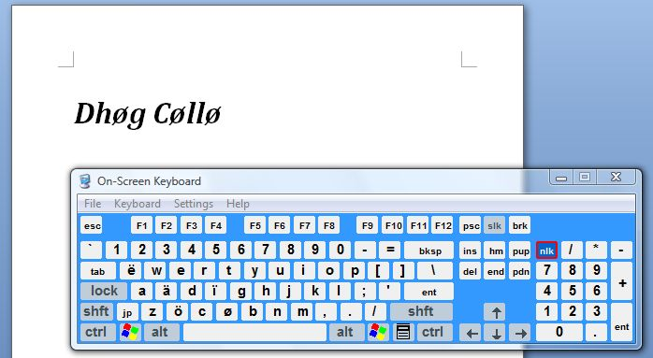

## Dhøg Cøllø layout

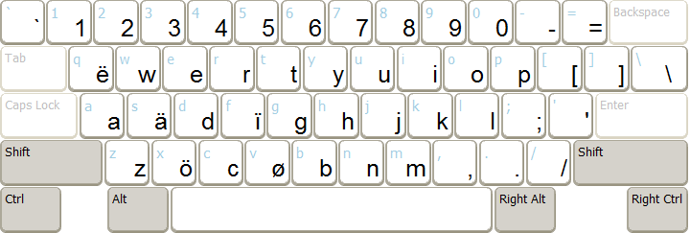

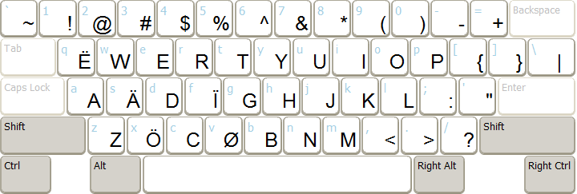

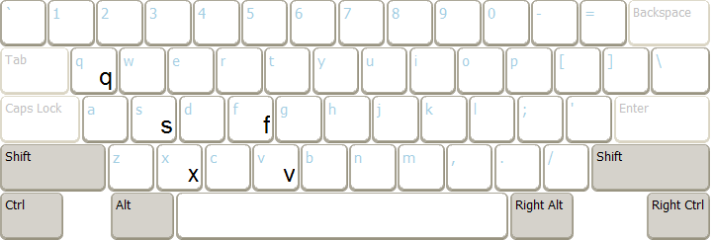

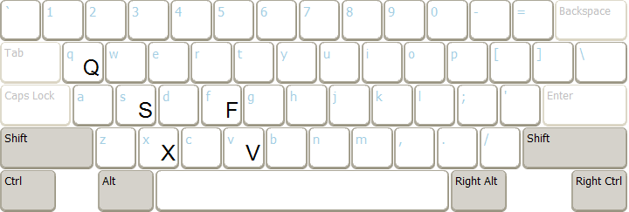

The **Dhøg Cøllø** keyboard layout has been designed to only type Chollo. The letters unique to Chollo replace letters that are not used in Chollo.

|  |  |  |  |  |  |  |  |  |  |  |
| --- | --- | --- | --- | --- | --- | --- | --- | --- | --- | --- |
| Press the key | s | S | q | Q | f | F | x | X | v | V |
| Types the letter | ä | Ä | ë | Ë | ï | Ï | ö | Ö | ø | Ø |

You can use press the AltGr (Right Alt) key and another key at the same time to type the missing English letters:

|  |  |  |  |  |  |  |  |  |  |  |
| --- | --- | --- | --- | --- | --- | --- | --- | --- | --- | --- |
| Press the keys | RALT + s | RALT + S | RALT + q | RALT + Q | RALT + f | RALT + F | RALT + x | RALT + X | RALT + v | RALT + V |
| To type the letter | s | S | q | Q | f | F | x | X | v | V |

## Dhøg Cøllø (QWERTY) layout

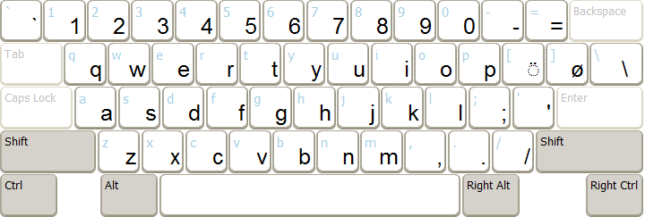

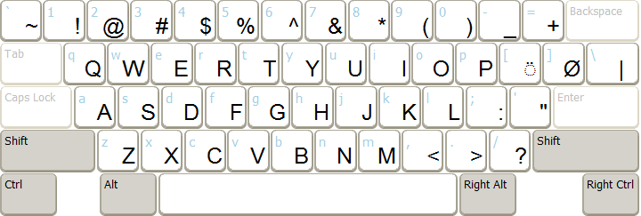

The **Dhøg Cøllø (QWERTY)** keyboard has been designed to type Chollo and English. Two keys have been added: a key for ø/Ø and a key for the diearesis ◌̈. To type a vowel with a diearesis you need to first type diearesis key then type the vowel (a, e, i or o).

|  |  |  |  |  |  |  |  |  |  |  |
| --- | --- | --- | --- | --- | --- | --- | --- | --- | --- | --- |
| Press the keys | [a | [A | [e | [E | [i | [I | [o | [O | ] | } |
| To type the letter | ä | Ä | ë | Ë | ï | Ï | ö | Ö | ø | Ø |